Group Member Contributions

Student Name | Student ID | Contribution % | Section Contributed
Romnic Francis | 4231634 | [ %]
Nathan Moniz | 4179499 | [ %]
Angeline Pacada | 4242703 | [ %]
Ramkrushna Bhadekar | 4178046 | [ %]

UrbanBuild AI Application Prototype
Prototype Link: https://yoga-yoga-65797768.figma.site
UrbanBuild AI (UBA) is an AI-driven platform designed to unify information for managing construction projects across Australia. It integrates internal and external data from third-party applications and acts as a single source of truth.

User Login
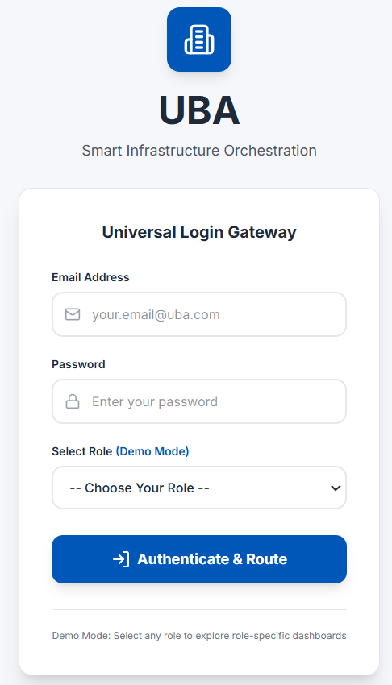
Figure 1. UBA Login*
Figure 1 shows the login page of the UBA application, the primary entry point for authorised users. This interface enables users to securely access the platform by submitting their login credentials for validation and authentication.
Upon successful verification of the provided credentials, users are granted access to the system based on their assigned roles and permissions. The login process ensures that only authorised personnel can access platform functionalities and project information, supporting system security, data protection, and compliance with access control requirements.
*Note: For the demo mode, any credentials can be used to access the prototype and “Select Role” was added to navigate the different dashboards of each role.

UBA User Roles
The current UBA prototype includes the critical roles in construction projects and in managing the application, including Site Worker, Site Supervisor, Project Manager, Logistics Coordinator, Safety Officer, and UBA Administrator.

Site Worker
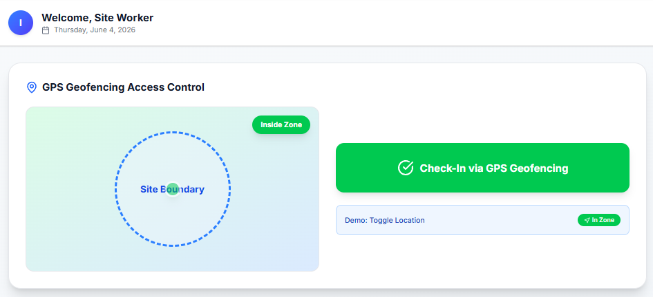
Figure 2. Site Worker (Check-in GPS Geofencing)
Figure 3. Check-out, Report Hazard, My Tasks, and Knowledge Kiosk (AR)
Figures 2 and 3 provide an overview of the functionalities currently supported by the prototype. These features include:

- GPS-based check-in geofencing
- GPS-based check-out geofencing
- Task viewing and updates
- Hazard reporting, including the identification and flagging of affected zones and the updating of the digital twin in the background
- Access to the Augmented Reality (AR) Knowledge Kiosk
- User and profile management

Also, the Site Worker module is integrated with several third-party applications, including SAP ERP and an authentication application, enabling seamless data exchange, secure user access, and enhanced operational efficiency across the platform.

Below is the created use case diagram for Site Worker. 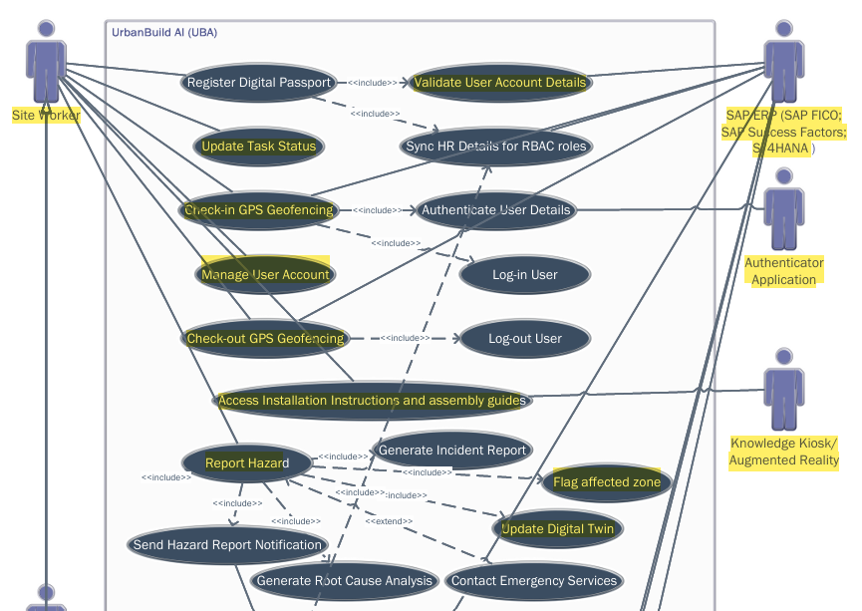
Figure 4. Site Worker Use Case (including validation and authentication)

Site Supervisor

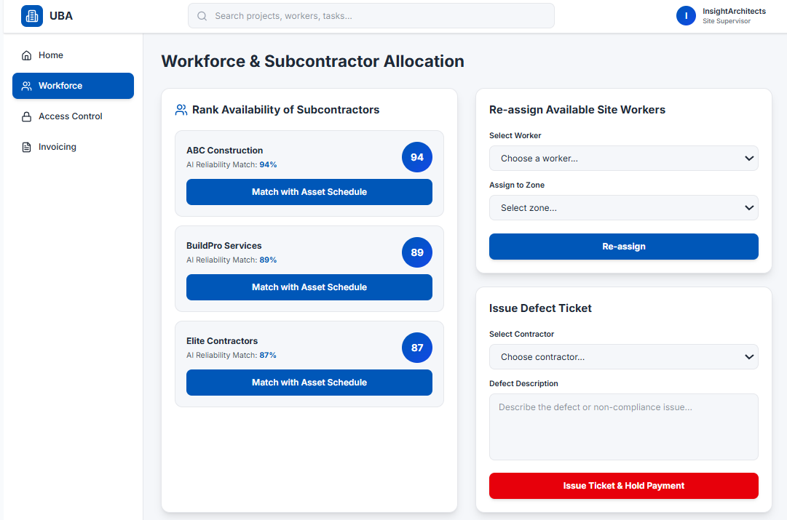
Figure 5. Workforce and Sub-contractor Allocation – Site Supervisor
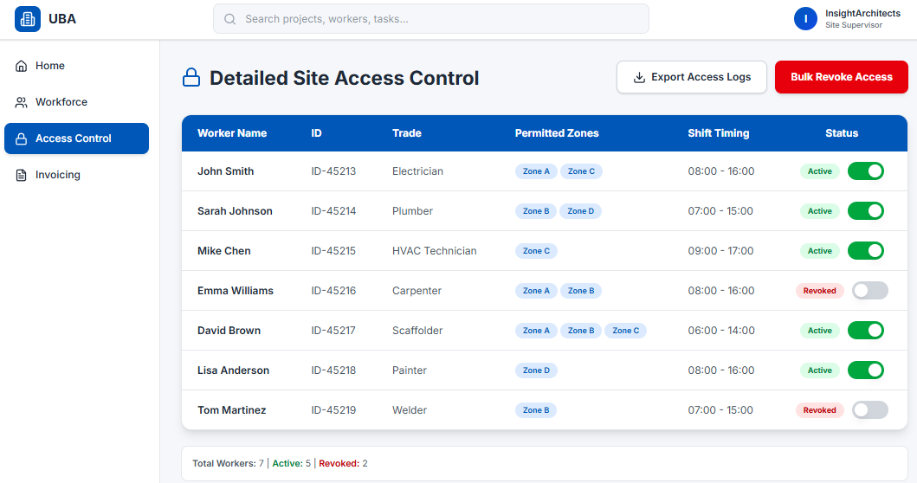
Figure 6. Detailed Site Access Control - Site Supervisor
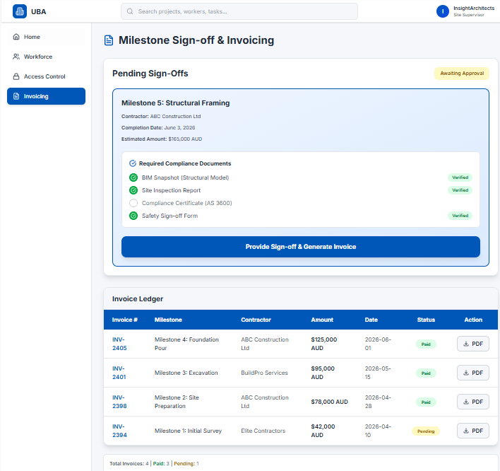
Figure 7. Milestone Sign-off & Invoicing – Site Supervisor
Figures 5, 6, and 7 illustrate the range of functions available to Site Supervisors within the UBA application. These functionalities include:

- Updating user account access permissions
- Ranking subcontractor availability, including matching subcontractor schedules with asset availability and project requirements
- Reassigning Site Workers to tasks or project areas
- Issuing defect tickets, including linking defects to the relevant Site Worker or Contractor profile, placing associated payments on hold, and automatically updating project schedules in the background
- Providing project sign-off, including the automated generation of a Digital Compliance Packet as a background process
- Generating invoices

The Site Supervisor module integrates with several third-party systems, including SAP ERP and the Digital Compliance Portal. These integrations enable streamlined project administration, automated compliance documentation, improved workforce coordination, and efficient financial and operational management across the platform.

Below is the created use case diagram for Site Supervisor.

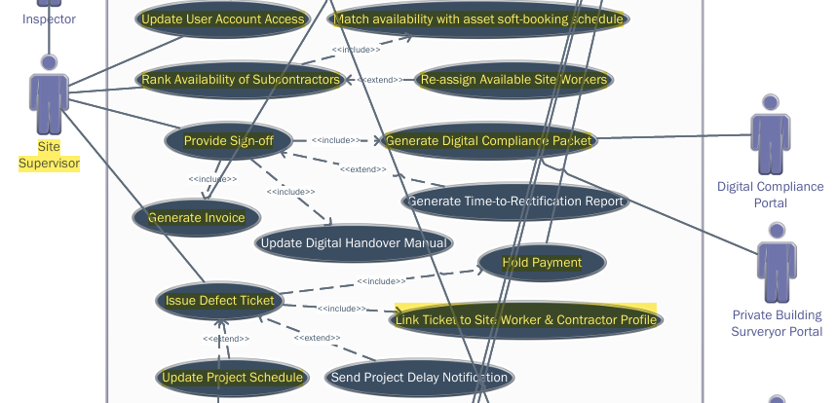
Figure 8. Site Supervisor Use Case

Project Manager

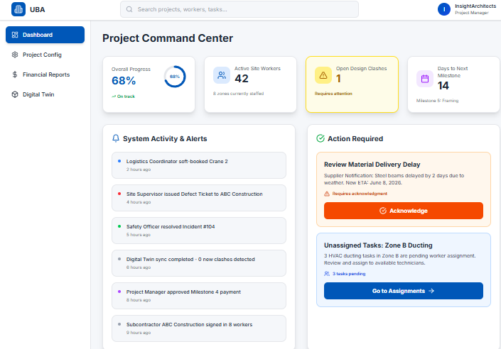
Figure 9. Project Command Center
Figure 9 presents the Project Manager Dashboard, which provides a consolidated view of key project performance indicators and management information. The dashboard enables project managers to monitor project status in real time and make informed decisions based on current operational data.

The dashboard displays the overall project progress, the number of active Site Workers, identified design clashes, and the remaining days until the next project milestone. It also provides visibility into recent system activities and alerts, ensuring that critical updates and potential issues are promptly communicated.

In addition, the dashboard highlights items requiring the Project Manager’s attention, allowing for timely action on pending approvals, project risks, resource constraints, compliance requirements, and other critical tasks. By centralising project information into a single interface, the dashboard supports proactive project oversight, improved coordination, and more efficient project delivery.

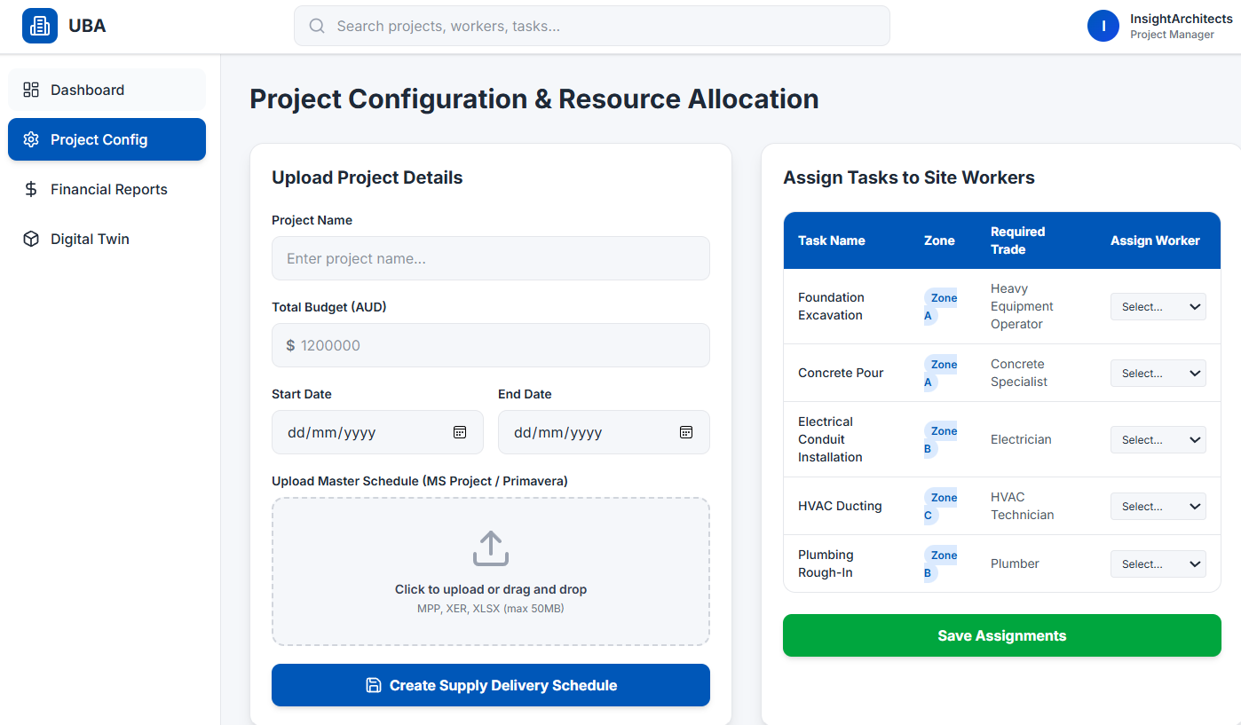
Figure 10. Project Configuration & Resource Allocation – Project Manager
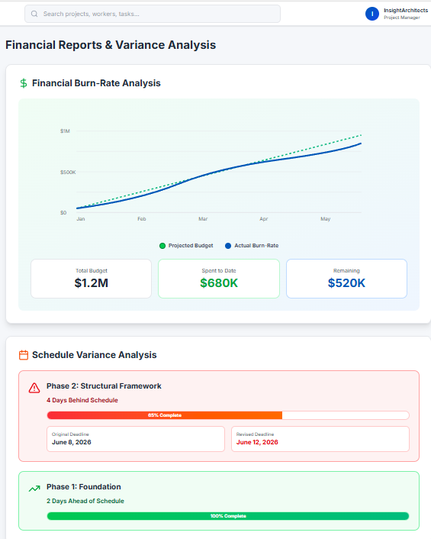
Figure 11. Financial Reports & Variance Analysis – Project Manager
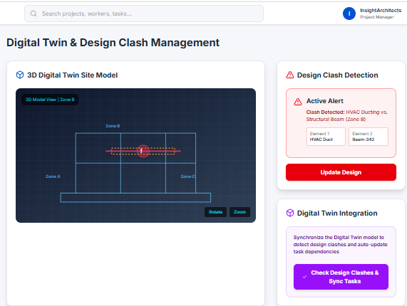
Figure 12. Digital Twin & Design Clash Management – Project Manager
Figures 10, 11, and 12 illustrate the key functionalities available to Project Managers within the UBA platform. These capabilities support project planning, design management, resource coordination, and performance monitoring throughout the project lifecycle. The functions include:

- Uploading project details, including the assignment of tasks to Site Workers, creation of supply delivery schedules, and generation of a project digital twin
- Generating financial burn-rate reports to monitor project expenditure against budget allocations
- Generating milestone variance analyses to assess deviations between planned and actual project performance
- Detecting design clashes within project models and drawings
- Updating project designs and associated documentation
- Reviewing and validating identified design clashes
- Synchronising project tasks and schedules based on approved design updates

These functionalities enable Project Managers to maintain control over project scope, schedule, cost, and design integrity while facilitating informed decision-making through real-time data and analytics.

The Project Manager module is integrated with several third-party applications, including Microsoft Project, Primavera, SAP ERP, and CAD systems. These integrations support seamless information exchange between project planning, financial management, design coordination, and construction execution processes, ensuring data consistency and improving overall project efficiency.

Below is the created use case diagram for Project Manager.
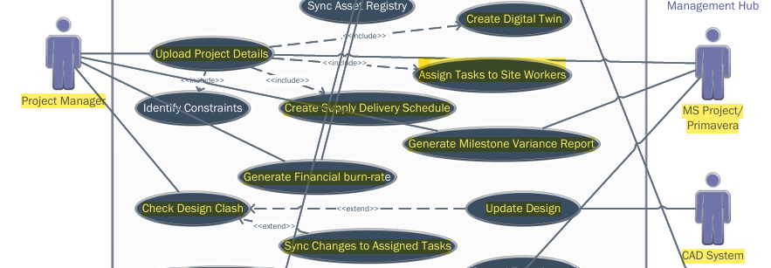
Figure 13. Project Manager Use Case

Logistics Coordinator

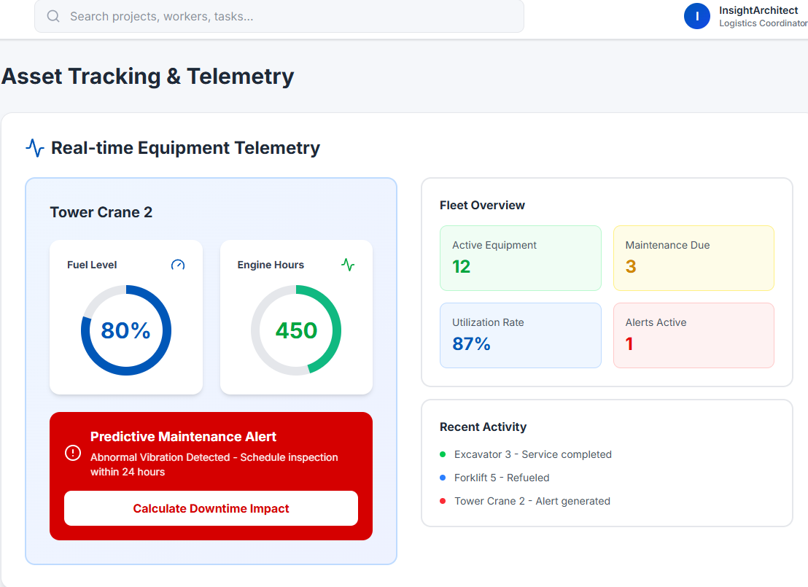
Figure 14. Asset Tracking & Telemetry
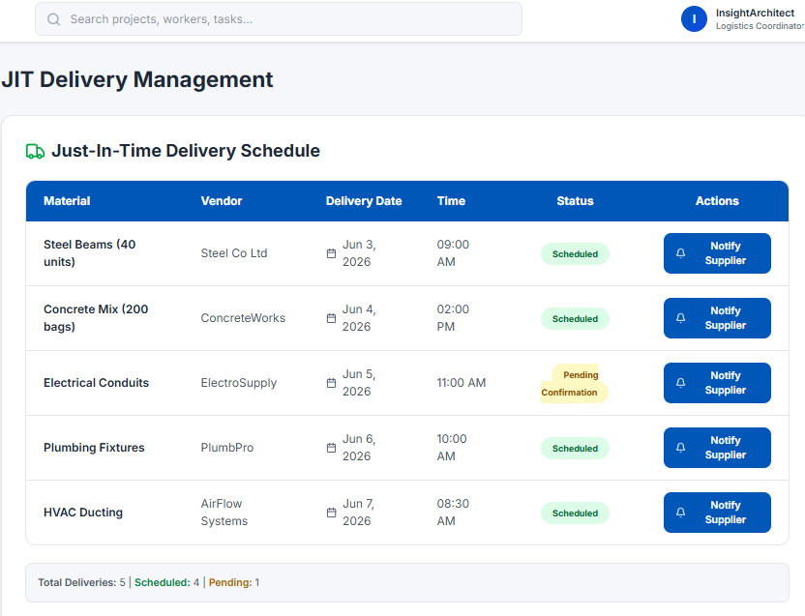
Figure 15. JIT Delivery Management
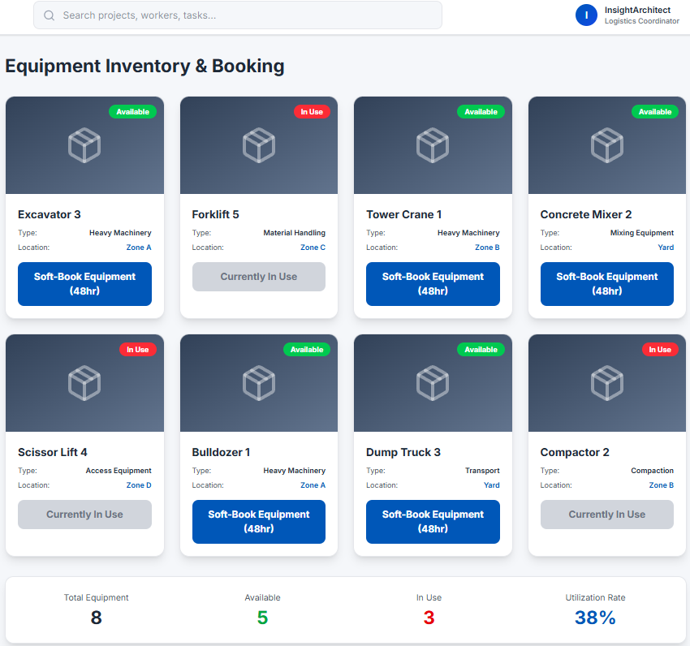
Figure 16. Equipment Inventory & Booking
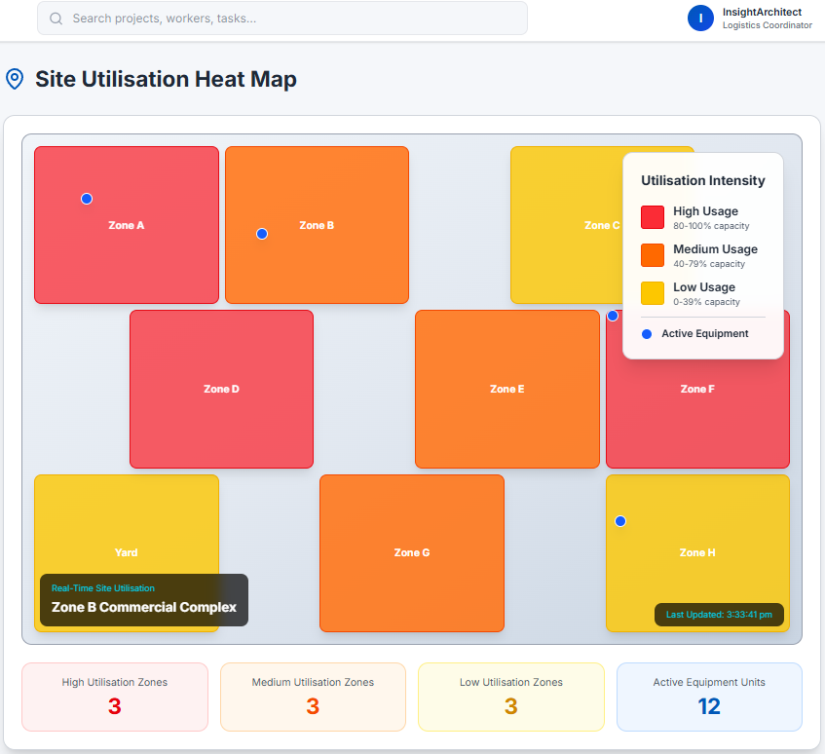
Figure 17. Site Utilisation Heat Map
Figures 14, 15, 16, and 17 illustrate the functionalities available to the Logistics Coordinator within the UBA platform. These capabilities are designed to support asset management, equipment utilisation, logistics planning, and operational efficiency across construction projects. The key functions include:

- Monitoring IoT telemetry data, including the generation of predictive maintenance alerts, issuance of crisis impact notifications, and calculation of the potential effects of asset downtime on project activities
- Managing Just-in-Time (JIT) delivery schedules, including updating project schedules and notifying suppliers of schedule changes
- Viewing utilisation heat maps to support resource allocation and optimisation
- Soft-booking machinery and equipment to facilitate advance planning and coordination of project resources

These functionalities provide Logistics Coordinators with real-time visibility into asset performance, equipment availability, and supply chain activities, enabling proactive decision-making and minimising disruptions to project operations.

The Logistics Coordinator module integrates directly with the Asset and IoT Management Hub, allowing seamless access to telemetry data, asset status information, utilisation analytics, and maintenance insights. This integration enhances operational planning, improves asset utilisation, and supports more efficient coordination of construction resources across multiple project sites.

Below is the created use case diagram for Logistics Coordinator.
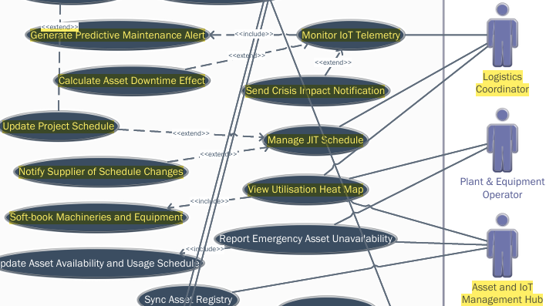
Figure 18. Logistics Coordinator Use Case

Safety Officer
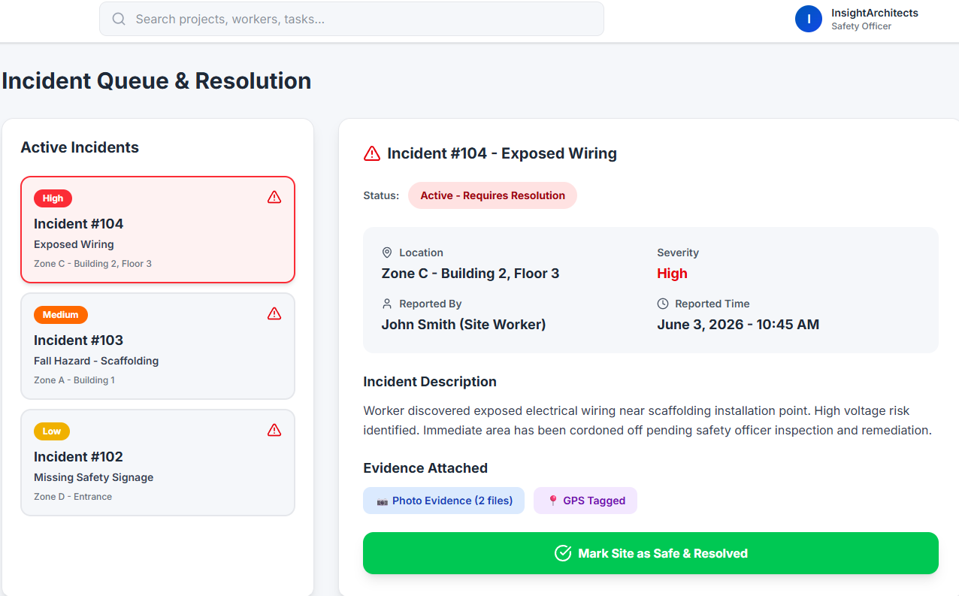
Figure 19. Incident Queue & Resolution
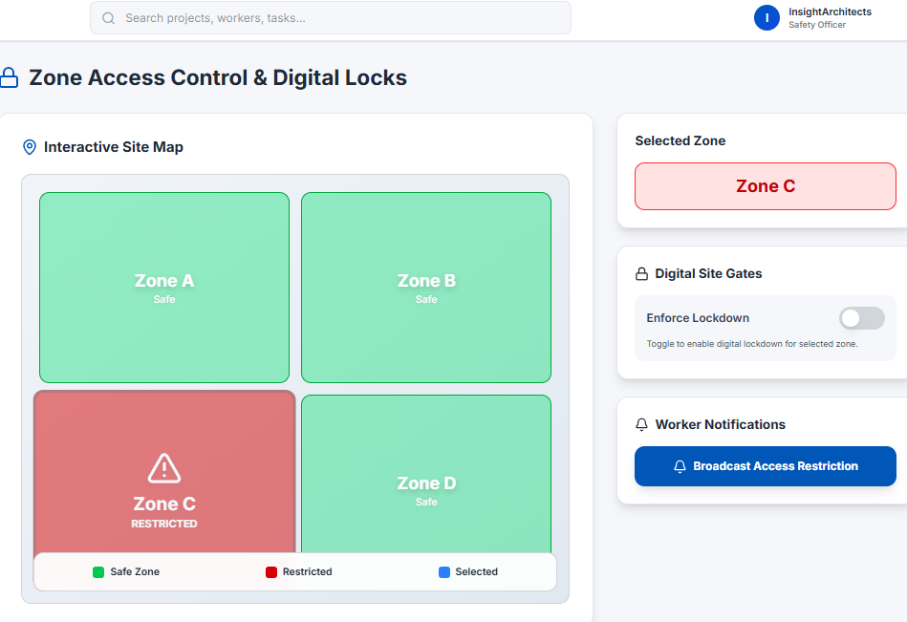
Figure 20. Zone Access Control & Digital Locks
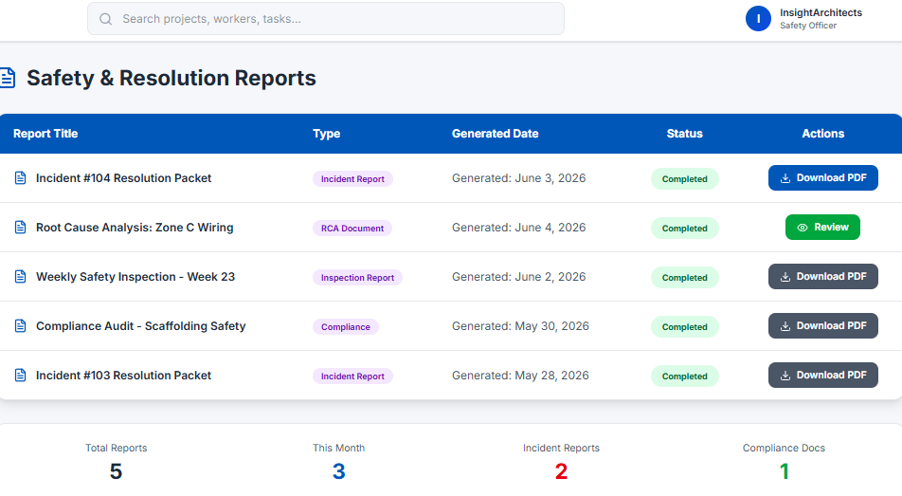
Figure 21. Safety & Resolution Reports
Figures 19, 20, and 21 illustrate the functionalities available to the Safety Officer within the UBA platform. These capabilities are designed to support site safety management, incident response, and regulatory compliance throughout construction operations. The key functions include:
- Controlling zone access, including the enforcement of digital locks and site gate restrictions, as well as the broadcasting of access control notifications to affected personnel
- Resolving incident reports, including the investigation and closure of reported incidents and the automated generation of incident resolution packets for documentation and compliance purposes
These functionalities enable Safety Officers to maintain a safe and controlled work environment by managing access to hazardous or restricted areas, responding promptly to safety incidents, and ensuring that corrective actions are properly documented and communicated.
The Safety Officer module integrates with the platform’s safety management and access control systems, facilitating real-time monitoring of site conditions, automated enforcement of safety protocols, and comprehensive incident documentation. This integration supports regulatory compliance, enhances worker safety, and promotes proactive risk management across construction projects.
Below is the created use case diagram for Safety Officer.
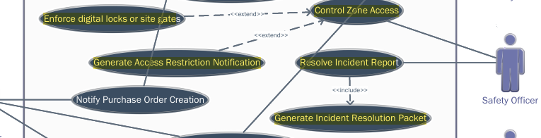
Figure 22. Safety Officer Use Case

UBA Administrator
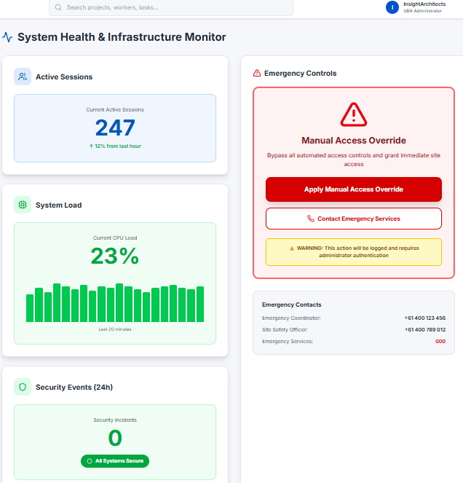
Figure 23. System Health & Infrastructure Monitor
Figure 23 presents the UBA Administrator Dashboard, which provides a centralised view of the platform’s operational status, security posture, and system performance. The dashboard is designed to support effective system administration, monitoring, and incident management across the UBA platform.
Key information displayed on the dashboard includes the number of active user sessions, overall system load, and logged security events. These metrics provide administrators with real-time visibility into platform usage, system health, and potential security concerns, enabling timely identification and resolution of operational issues.
In addition to monitoring capabilities, the dashboard provides administrative functions such as manual access override and emergency services contact management. The manual access override feature allows authorised administrators to grant or restrict access when exceptional circumstances arise, ensuring business continuity while maintaining system security. The emergency services functionality facilitates rapid communication and coordination during critical incidents, supporting effective emergency response and site safety management.
By consolidating system monitoring, security oversight, and administrative controls within a single interface, the UBA Administrator Dashboard enhances operational governance, improves incident response capabilities, and supports the secure and reliable operation of the platform.
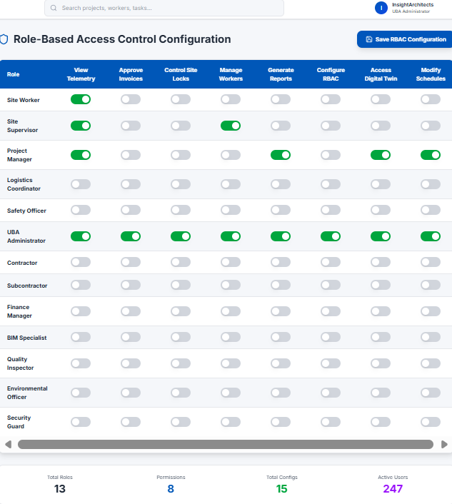
Figure 24. Role-Based Access Control Configuration
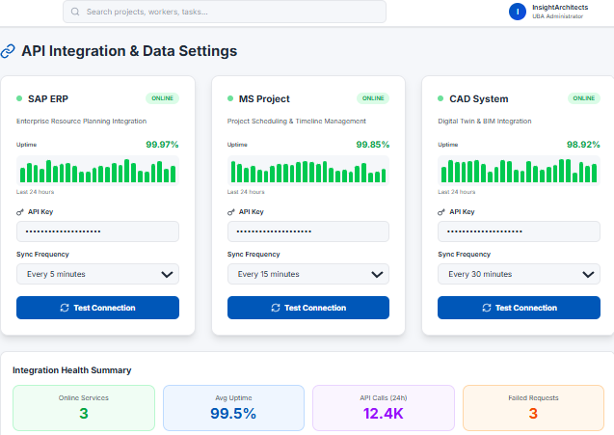
Figure 25. API Integration & Data Settings

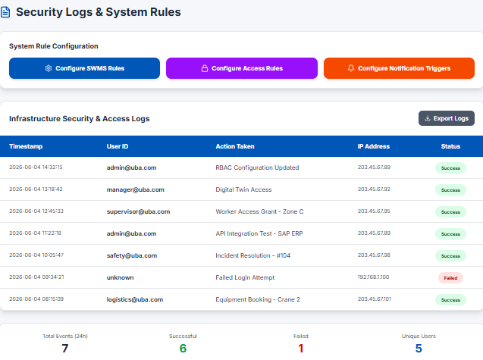
Figure 26. Security Logs & System Rules
Moreover, Figures 24, 25, and 26 illustrate additional administrative and system configuration modules within the UBA platform. These modules provide the tools required to manage user permissions, system integrations, governance policies, and automated workflows. The key functionalities include:

- Configuration of Role-Based Access Control (RBAC) roles
- Configuration of user account access permissions
- API management and integration administration
- Configuration of Safe Work Method Statement (SWMS) rules
- Configuration of site access and security rules
- Configuration of notification triggers and automated alerts

These modules enable administrators to establish and maintain the operational rules, security controls, and integration settings that govern the platform. Through RBAC and user access management, administrators can ensure that users are granted appropriate permissions based on their roles and responsibilities, thereby strengthening security and compliance.

The API management module facilitates the integration of external systems and services, supporting seamless data exchange across the UBA ecosystem. Meanwhile, the SWMS and access rule configuration modules allow organisations to align platform operations with safety requirements, regulatory obligations, and project-specific procedures.

In addition, the notification trigger configuration functionality enables the automation of alerts, reminders, approvals, and exception reporting based on predefined business rules. Collectively, these modules provide the flexibility, governance, and administrative control necessary to support secure, scalable, and efficient platform operations across multiple projects and stakeholders.

Below is the created use case diagram for UBA Administrator.
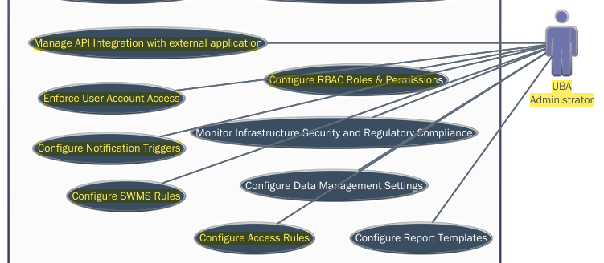
Figure 27. UBA Administrator Use Case

Incident Reporting
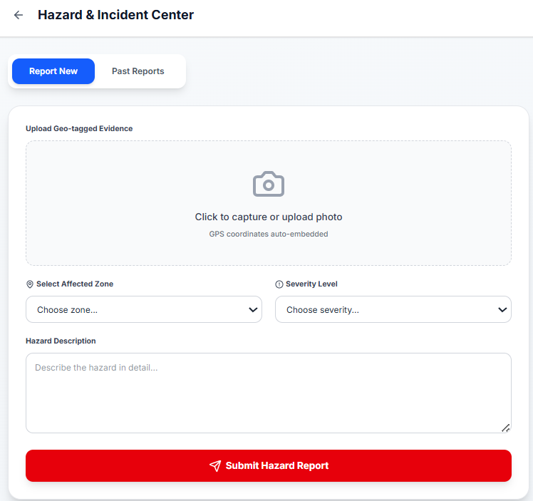
Figure 28. Submit Hazard Report Module - Site Worker
Figure 29. Past Report Dashboard - Site Worker

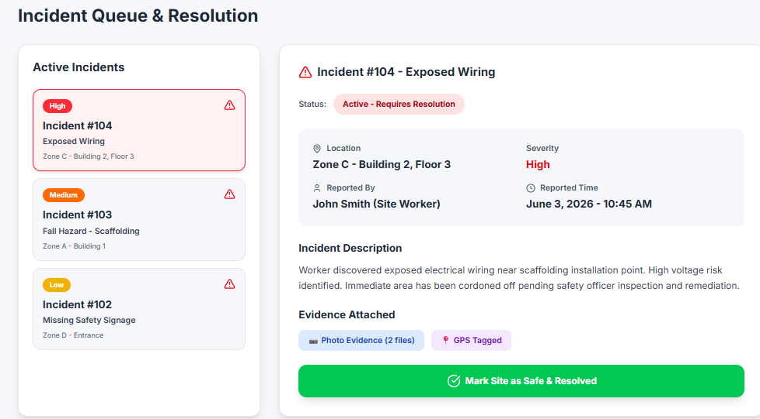
Figure 30. Incident Queue & Resolution Module
Figures 28, 29, and 30 show the different states of an incident report in the UBA prototype. The incident report transitions to states through triggers incorporated into the UBA application based on the state machine diagrams from Figure 31.A and 31.B. Below are the different states reflected in the prototype.

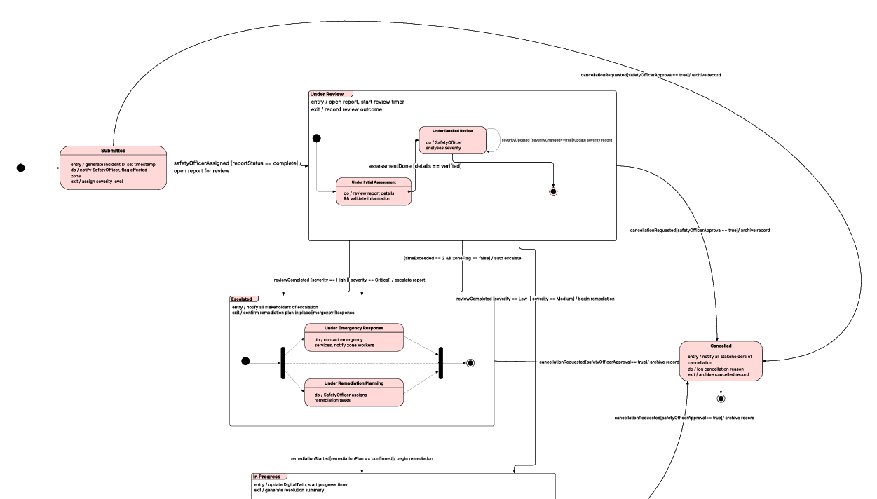
Figure 31.A State Machine Diagram - Incident Report
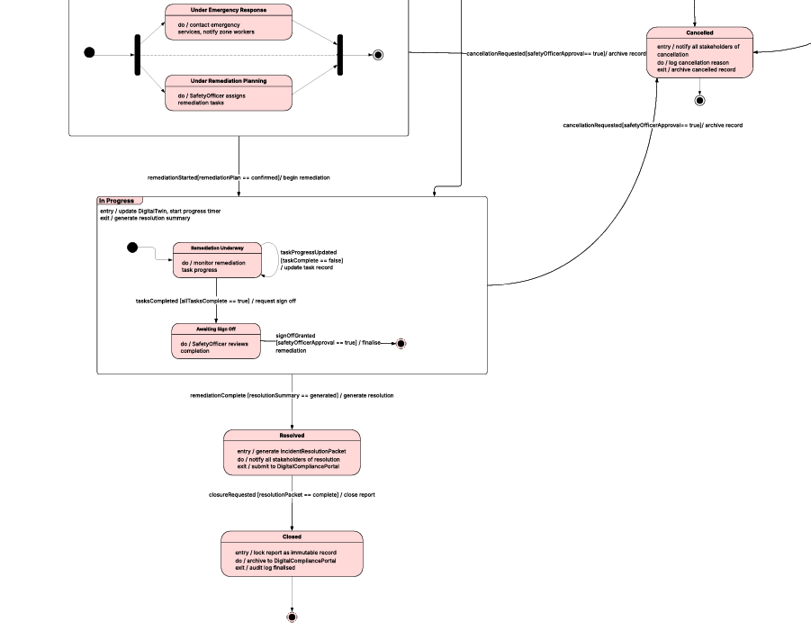
Figure 31.B State Machine Diagram – Incident Report
Submitted
Once the Site Worker submits the complete IncidentReport details, the status automatically changes to Submitted.
Under Review
When the assigned Safety Officer opens the IncidentReport for review, the status changes to Under Review. This state contains two substates: Under Initial Assessment and Under Detailed Review. During Under Initial Assessment, the Safety Officer validates the report details. During Under Detailed Review, the accuracy of the assigned severity level is verified.
Escalated
An IncidentReport assessed as high to critical severity, or one that exceeds the maximum allowable review time, transitions to Escalated. This triggers emergency response and remediation planning, both of which proceed simultaneously.
In Progress
An IncidentReport with low to medium severity transitions from Under Review to In Progress. This state contains two substates: Remediation Underway and Awaiting Review Sign-off. During Remediation Underway, remediation tasks are executed. Once all tasks are completed, the IncidentReport moves to Awaiting Review Sign-off for Safety Officer verification.
Resolved
An IncidentReport moves to the Resolved state once all remediation tasks are completed and verified by the Safety Officer. The system generates a resolution packet at this point.
Cancelled
An IncidentReport in any state from Submitted through to In Progress moves to Cancelled upon Safety Officer approval of a cancellation request.

Prototype Aesthetics
The UBA prototype was designed to achieve a professional, modern appearance, with the main objective of delivering a user-friendly interface for non-technical construction industry users.
A blue and white color scheme was used to establish a clean, professional, and uncluttered visual identity. Additional colors such as green, red, orange, and yellow were applied to represent system status, alerts, warnings, and successful actions, enabling users to quickly interpret information without relying on lengthy text.
The interface adopts simple card-based layouts, large buttons, and clearly separated sections, ensuring intuitive navigation even for users with limited technical experience. A clear visual hierarchy was implemented through varied heading sizes and text styles, allowing users to easily distinguish between screen titles, section headers, and detailed content.
To enhance usability, each user role is assigned a customised dashboard displaying only relevant tools and information, reducing clutter and supporting task-focused interaction. The prototype also integrates modern UI components such as interactive cards, dashboards, status indicators, maps, charts, toggle switches, and system activity logs.
Overall, the aesthetic design of the UBA prototype balances professionalism, functionality, and visual clarity, reflecting the innovative, technology-driven nature of modern construction project management.

